

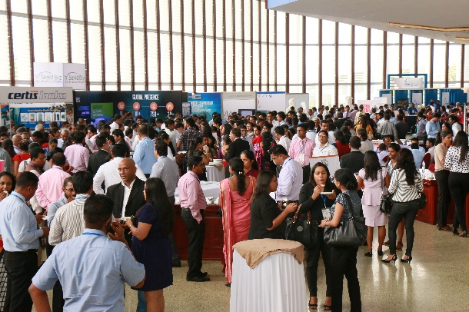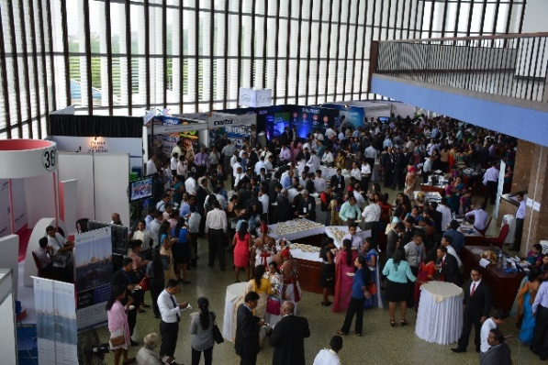

**Date : 20th and 21st June 2017**

**Venue : Delegates’ Lounge, BMICH, Colombo**

**Contact : Dulani – T:** [**0112199988, Mob : 0717742244 dulani@ipmlk.org**](mailto:0112199988,%20Mob%20:%200717742244%20%20%20%20%20%20%20%20%20%20%20%20%20%20%20%20%20%20%20%20%20%20%20%20%20%20%20%20%20%20%20%20%20%20%20%20%20%20%20%20%20%20%20%20%20%20%20%20%20%20%20%20%20%20%20%20%20%20%20%20%20%20%20%20%20%20%20%20%20%20%20%20%20%20%20%20%20%20%20%20%20dulani@ipmlk.org)

**Gayan – 0714351780, Milinda – 0776376026**

**NATIONAL HR EXHIBITION 2017**

**HALF PAGE BLACK AND WHITE ADVERTISEMENT**

**FOR NATIONAL HR EXHIBITORS 2017**

**FREE**

|  |  |
| --- | --- |
| **STALL DETAILS** | |
| **Platinum Package** : [Delegates’ Lounge] | 55,000 LKR* (Early Bird – 49,500 LKR*) |
| **Gold Package** : [Delegates’ Lounge] | 50,000 LKR* (Early Bird – 45,000 LKR*) |
| **Silver Package** : [Delegates’ Lounge] | 45,000 LKR* (Early Bird – 40,500 LKR*) |
| **Every Package includes:** | 1 No. Counter |
| 2 Nos. Folding Chairs |
| 1 No. 5A Plug |
| 1 No. Name Board |
| 2 Nos. Spot lights |
| Shell Scheme - 3m x 3m x 2.5m [if required] |
| **Add-ons to the package :** | Free half page black and white advertisement in the Exhibition Catalogue. Exhibition Catalogue will be given to 1000 + conference participants along with the other Conference Material. |
| Lunch and Tea for two representatives for both days. |
| **Advertisements on the Exhibition Catalogue** *(Pay only the balance amount when upgrading your Free B/W Advertisement!!!)* | Half Page B/W Rs. 3,500/= + 2% NBT  Half Page Coloured Rs. 5,000/= + 2% NBT  Full Page B/W Rs. 7,000 /= + 2% NBT  Full Page Coloured Rs. 10,000/= + 2% NBT |
| *\* Payment exclusive of NBT* | |

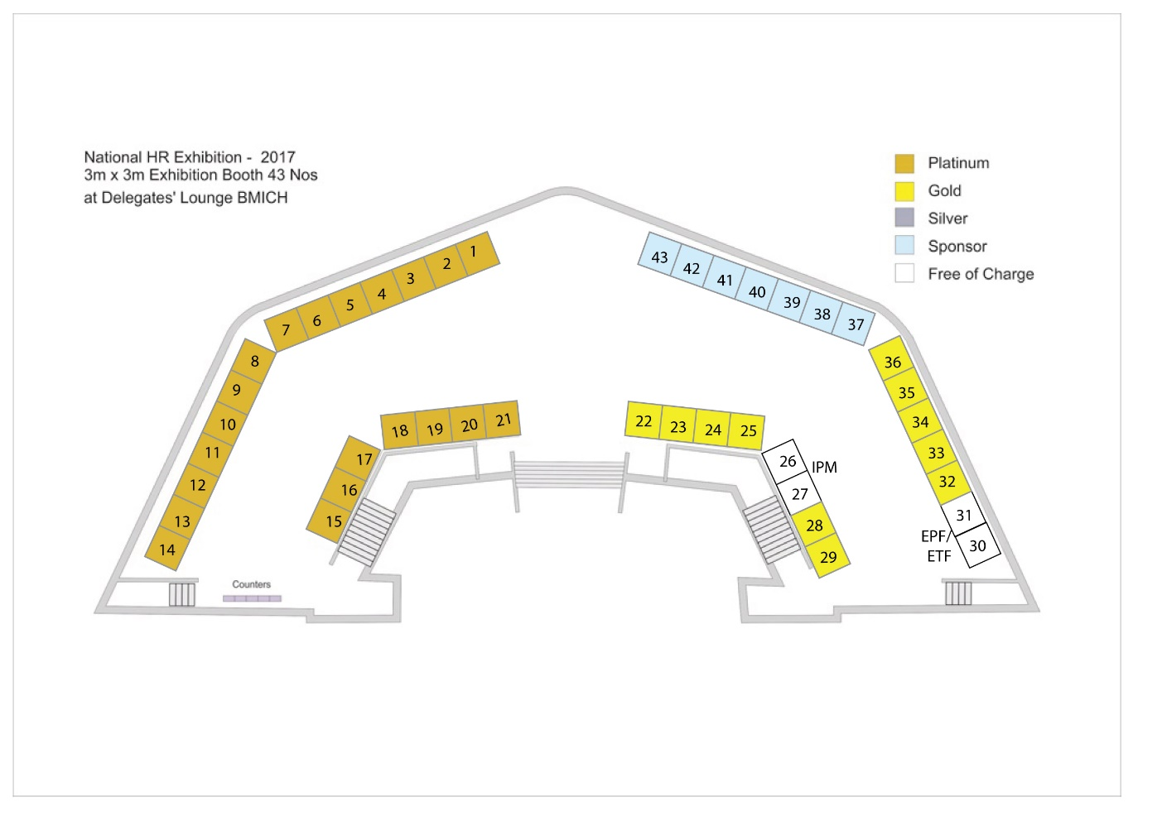

**FLOOR PLAN: Delegates’ Lounge**

**Exhibition Catalogue: Advertisement Specifications**

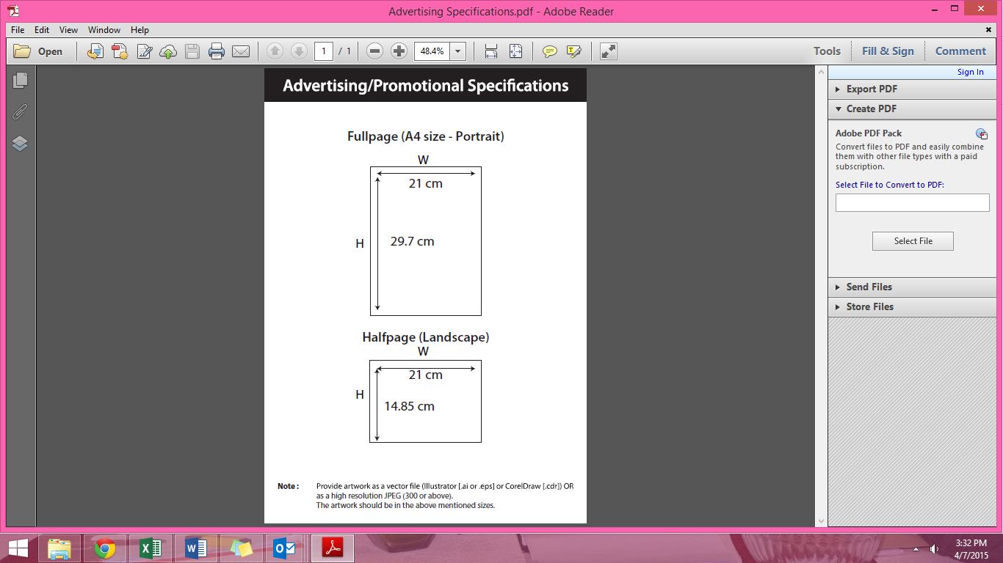

**NATIONAL H R EXHIBITION 2017**

**Exhibitor Application Form**

**Contact Details**

Company Name:

|  |  |  |  |  |  |  |  |  |  |  |  |  |  |  |  |  |  |  |  |  |  |  |  |  |  |  |  |  |  |  |  |  |
| --- | --- | --- | --- | --- | --- | --- | --- | --- | --- | --- | --- | --- | --- | --- | --- | --- | --- | --- | --- | --- | --- | --- | --- | --- | --- | --- | --- | --- | --- | --- | --- | --- |
|  |  |  |  |  |  |  |  |  |  |  |  |  |  |  |  |  |  |  |  |  |  |  |  |  |  |  |  |  |  |  |  |  |

C E O / M D’ Name:

|  |  |  |  |  |  |  |  |  |  |  |  |  |  |  |  |  |  |  |  |  |  |  |  |  |  |  |  |  |  |  |  |  |
| --- | --- | --- | --- | --- | --- | --- | --- | --- | --- | --- | --- | --- | --- | --- | --- | --- | --- | --- | --- | --- | --- | --- | --- | --- | --- | --- | --- | --- | --- | --- | --- | --- |
|  |  |  |  |  |  |  |  |  |  |  |  |  |  |  |  |  |  |  |  |  |  |  |  |  |  |  |  |  |  |  |  |  |

Address:

|  |  |  |  |  |  |  |  |  |  |  |  |  |  |  |  |  |  |  |  |  |  |  |  |  |  |  |  |  |  |  |  |  |
| --- | --- | --- | --- | --- | --- | --- | --- | --- | --- | --- | --- | --- | --- | --- | --- | --- | --- | --- | --- | --- | --- | --- | --- | --- | --- | --- | --- | --- | --- | --- | --- | --- |
|  |  |  |  |  |  |  |  |  |  |  |  |  |  |  |  |  |  |  |  |  |  |  |  |  |  |  |  |  |  |  |  |  |
|  |  |  |  |  |  |  |  |  |  |  |  |  |  |  |  |  |  |  |  |  |  |  |  |  |  |  |  |  |  |  |  |  |

Country:

|  |  |  |  |  |  |  |  |  |  |  |  |  |  |  |  |  |  |  |  |  |  |  |  |  |  |  |  |  |  |  |  |  |
| --- | --- | --- | --- | --- | --- | --- | --- | --- | --- | --- | --- | --- | --- | --- | --- | --- | --- | --- | --- | --- | --- | --- | --- | --- | --- | --- | --- | --- | --- | --- | --- | --- |
|  |  |  |  |  |  |  |  |  |  |  |  |  |  |  |  |  |  |  |  |  |  |  |  |  |  |  |  |  |  |  |  |  |

Telephone:

|  |  |  |  |  |  |  |  |  |  |  |  |  |  |  |  |  |  |  |  |  |  |  |  |  |  |  |  |  |  |  |  |  |
| --- | --- | --- | --- | --- | --- | --- | --- | --- | --- | --- | --- | --- | --- | --- | --- | --- | --- | --- | --- | --- | --- | --- | --- | --- | --- | --- | --- | --- | --- | --- | --- | --- |
|  |  |  |  |  |  |  |  |  |  |  |  |  |  |  |  |  |  |  |  |  |  |  |  |  |  |  |  |  |  |  |  |  |

E-mail:

|  |  |  |  |  |  |  |  |  |  |  |  |  |  |  |  |  |  |  |  |  |  |
| --- | --- | --- | --- | --- | --- | --- | --- | --- | --- | --- | --- | --- | --- | --- | --- | --- | --- | --- | --- | --- | --- |
|  |  |  |  |  |  |  |  |  |  |  |  |  |  |  |  |  |  |  |  |  |  |

Fax:

|  |  |  |  |  |  |  |  |  |  |  |  |  |  |  |
| --- | --- | --- | --- | --- | --- | --- | --- | --- | --- | --- | --- | --- | --- | --- |
|  |  |  |  |  |  |  |  |  |  |  |  |  |  |  |

Contact Person Mr/Ms:

|  |  |  |  |  |  |  |  |  |  |  |  |  |  |  |  |  |  |  |  |  |  |  |  |  |  |  |  |  |  |  |  |  |
| --- | --- | --- | --- | --- | --- | --- | --- | --- | --- | --- | --- | --- | --- | --- | --- | --- | --- | --- | --- | --- | --- | --- | --- | --- | --- | --- | --- | --- | --- | --- | --- | --- |
|  |  |  |  |  |  |  |  |  |  |  |  |  |  |  |  |  |  |  |  |  |  |  |  |  |  |  |  |  |  |  |  |  |
|  |  |  |  |  |  |  |  |  |  |  |  |  |  |  |  |  |  |  |  |  |  |  |  |  |  |  |  |  |  |  |  |  |

Position of contact person:

|  |  |  |  |  |  |  |  |  |  |  |  |  |  |  |  |  |  |  |  |  |  |  |  |  |  |  |  |  |  |
| --- | --- | --- | --- | --- | --- | --- | --- | --- | --- | --- | --- | --- | --- | --- | --- | --- | --- | --- | --- | --- | --- | --- | --- | --- | --- | --- | --- | --- | --- |
|  |  |  |  |  |  |  |  |  |  |  |  |  |  |  |  |  |  |  |  |  |  |  |  |  |  |  |  |  |  |

VAT registration No:

|  |  |  |  |  |  |  |  |  |  |  |  |  |  |  |  |  |  |  |  |  |  |  |  |  |  |  |  |  |  |  |  |  |
| --- | --- | --- | --- | --- | --- | --- | --- | --- | --- | --- | --- | --- | --- | --- | --- | --- | --- | --- | --- | --- | --- | --- | --- | --- | --- | --- | --- | --- | --- | --- | --- | --- |
|  |  |  |  |  |  |  |  |  |  |  |  |  |  |  |  |  |  |  |  |  |  |  |  |  |  |  |  |  |  |  |  |  |

**Exhibition Space**

|  |  |  |  |  |
| --- | --- | --- | --- | --- |
| Stall Location / N0. | No. of stalls | Discounted Unit Price | NBT (02%) | Total Cost |
|  |  |  |  |  |
|  |  |  |  |  |

Size/Colour of the advertisement

|  |  |  |  |  |
| --- | --- | --- | --- | --- |
| Half page black | Full page black | Half page colour | Full page colour | Total Cost |
| Rs. 3,500 | Rs. 7,000 | Rs. 5,000 | Rs.10,000 |  |
| Free of charge for Exhibitors |  |  |  |  |

All payments should be made by a cheque drawn in favor of “Institute of personnel Management Sri Lanka” Crossed “Account Payee Only”.

Signature and Company seal :

Date :

Name :

Designation :